Project 1: Network Monitoring Lab
Objective: Capture and analyze real-time network traffic to understand protocol behavior. [1]
1. Install Wireshark
- Download: Get the installer for your OS directly from the Wireshark Downloads Page.
- Prerequisites: Ensure Npcap (packaged with the Windows installer) is allowed to install as it provides the packet capturing driver.
- Linux: Often pre-installed on distros like Kali Linux. If not, use sudo apt update && sudo apt install wireshark. [1, 2, 3, 4, 5]
2. Capture Traffic
- Launch Wireshark and select the active network interface (e.g., Ethernet or Wi-Fi).
- Click the blue shark fin icon (Start Capture).
- Generate test traffic by browsing websites or pinging internal devices, then click the red square button to stop the capture. [1, 2, 3, 4]
3. Document Findings (Lab Report)
- Protocol Analysis: Filter the capture using http, dns, or tcp to observe the three-way handshake.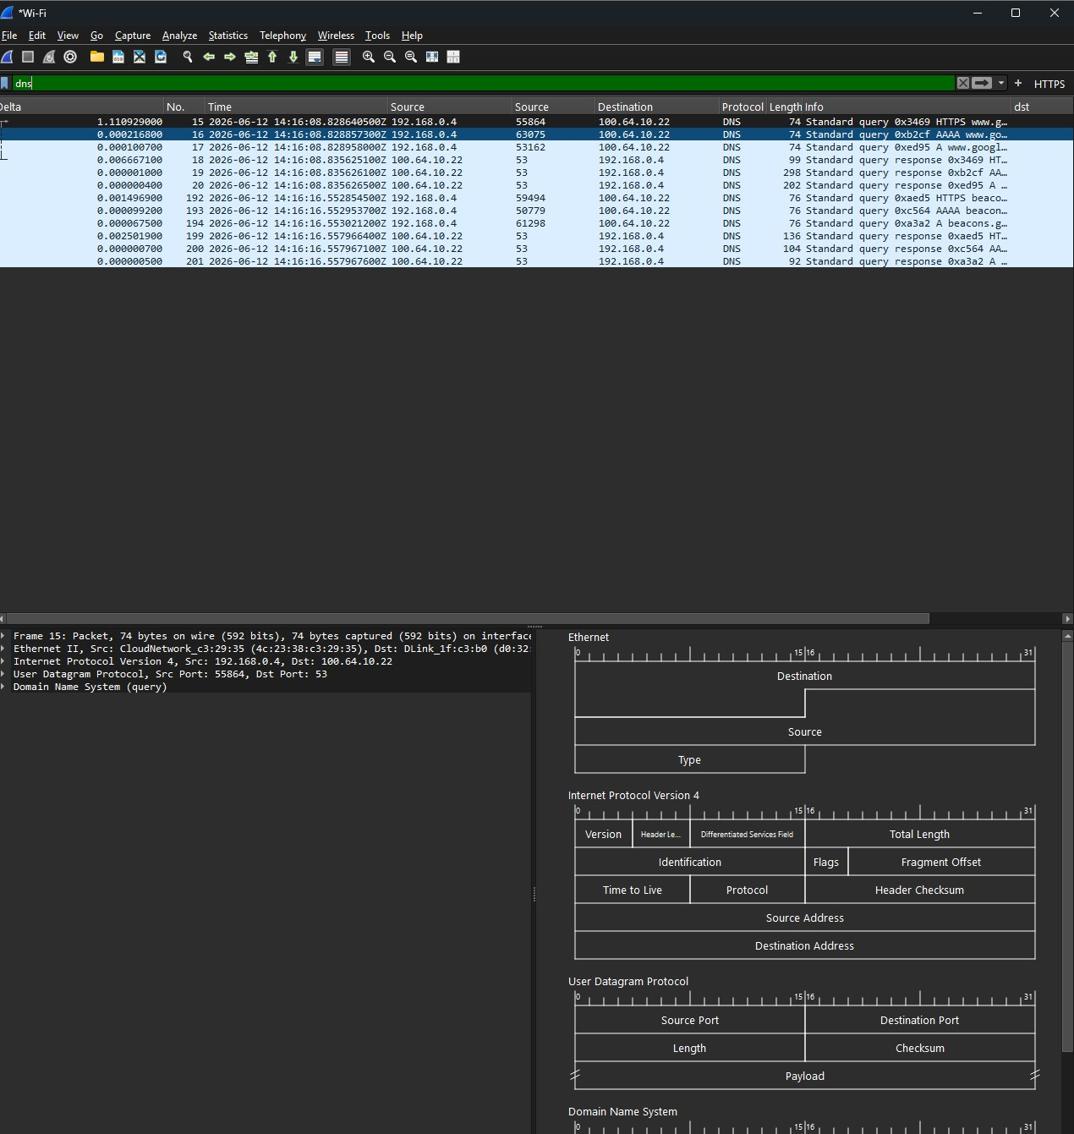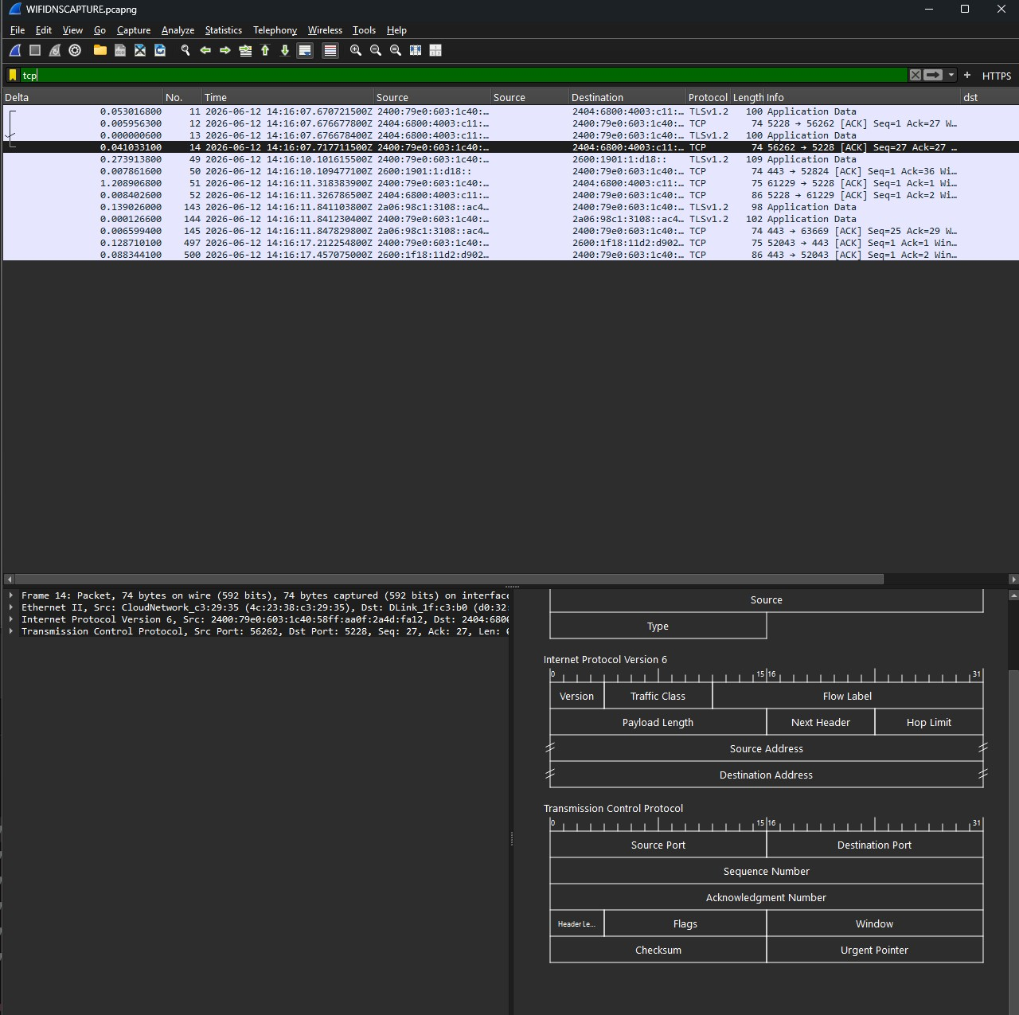
- Deliverable: Export your trace as a .pcap file. Write a short report highlighting packet structures, IP addresses of communicating devices, and any unencrypted data transmissions observed

Short DNS Packet Capture Report
1. Overview
The packet capture shows Domain Name System (DNS) traffic between a client device and a DNS resolver. DNS is used to translate domain names into IP addresses before establishing network connections.
The capture contains DNS queries and responses transmitted over UDP port 53.

2. Packet Structure Observed
The selected packet (Frame 15) contains the following protocol layers:
Layer 2 – Ethernet II
- Source MAC: 4c:23:38:c3:29:35
- Destination MAC: d0:32...
Layer 3 – Internet Protocol Version 4 (IPv4)
- Source IP: 192.168.0.4
- Destination IP: 100.64.10.22
Layer 4 – User Datagram Protocol (UDP)
- Source Port: 55864
- Destination Port: 53 (DNS)
Layer 7 – Domain Name System (DNS)
- Standard DNS query
- Query type visible as HTTPS record lookup
- Domain name partially visible as:
  - www.google...
Packet encapsulation:
Ethernet → IPv4 → UDP → DNS

3. Communicating Devices
Device | IP Address | Role
Client Host | 192.168.0.4 | Sends DNS requests
DNS Resolver | 100.64.10.22 | Returns DNS responses
The client is requesting domain name resolution services from the DNS server.

4. DNS Activity Observed
The packet list shows:
DNS Queries
- HTTPS record lookup for www.google...
- A record lookup
- AAAA record lookup
- Additional lookups for domains beginning with:
  - beacon...
  - g...
DNS Responses
The DNS server responds with:
- A records (IPv4 addresses)
- AAAA records (IPv6 addresses)
- HTTPS resource records
This indicates the client is preparing to establish connections to external services.

5. Unencrypted Data Transmission Analysis
Unencrypted Information Found
Unlike the TLS capture, DNS traffic is visible in plaintext.
The following information can be observed:
- Source IP address: 192.168.0.4
- DNS server address: 100.64.10.22
- Requested domain names (e.g., www.google...)
- Query types:
  - A
  - AAAA
  - HTTPS
Because traditional DNS over UDP/53 does not encrypt packet contents, anyone with access to the network segment could potentially see:
- Which websites are being queried
- Timing of requests
- Client and DNS server addresses
Sensitive Data
No passwords, login credentials, or application content are visible.
However, DNS queries can reveal:
- Browsing activity
- Services being accessed
- Network usage patterns

6. Security Assessment
Positive Findings
- No sensitive user credentials observed.
- Only DNS resolution traffic is visible.
Security Concern
- DNS requests appear to be transmitted using standard DNS over UDP port 53.
- Domain names are visible in plaintext.
- This traffic lacks the confidentiality provided by:
  - DNS over HTTPS (DoH)
  - DNS over TLS (DoT)

7. Conclusion
The capture shows a host (192.168.0.4) communicating with a DNS resolver (100.64.10.22) using standard DNS over UDP port 53. The packet structure consists of Ethernet, IPv4, UDP, and DNS headers. Unlike the previous TLS capture, this traffic exposes domain lookup information in plaintext, allowing queried hostnames and DNS metadata to be observed. No sensitive application data or credentials were visible, but website lookup activity could be monitored by anyone with access to the network path.

